**MAWLANA BHASHANI SCIENCE AND TECHNOLOGY UNIVERSITY**

**SANTOSH, TANGAIL-1902**



**DEPARTMENT OF INFORMATION AND COMMUNICATION TECHNOLOGY**

**Lab Report No: 02**

**Course Title:** Communication Engineering Lab

**Course Code:** ICT-2206

**Lab Report on:** Phase Modulation and Demodulation

|  |  |
| --- | --- |
| **Submitted By** | **Submitted To** |
| **Name: Kuldip Saha Mugdha**  **ID: IT-22018**  **2nd Year, 2nd Semester**  **Session: 2021-2022**  **Dept. of ICT, MBSTU** | **Dr. Monir Morshed**  **Professor**  **Department of Information and Communication Technology**  **Mawlana Bhashani Science and Technology University** |

**Date of Performance: 09/03/2025 Date of Submission: 12/03/2025**

**Introduction:**

Phase Modulation (PM) is a technique where the phase of a high-frequency carrier signal is varied according to the instantaneous amplitude of a message signal. It is widely used in digital and analog communication systems, such as in FM radio and wireless communication.

**Equipments:**

1.Signal Generator

2.Oscilloscope

3.Cable

4.MATLAB

5.Power supply

6.Function generator

**Theory:**

In Phase Modulation (PM), the instantaneous phase of the carrier signal changes with the message signal. The PM signal is given by:



Demodulation is done using a phase-locked loop (PLL) or a differentiator to extract the original message signal.

**Procedure:**

**1. Generate Signals**

* Create a message signal (low-frequency sine wave).
* Generate a carrier signal (high-frequency cosine wave).

**2. Apply Phase Modulation**

* Modulate the carrier by varying its phase in proportion to the message signal.
* Observe how the phase shifts with amplitude changes in the message signal.

**3. Visualization of Signals**

* Plot the message signal, carrier signal, and phase-modulated signal.

**4. Transmission of PM Signal**

* Simulate transmission through a channel using MATLAB.

**5. Demodulation Process**

* Use a phase-locked loop (PLL) to extract the message signal.
* The PLL locks onto the carrier frequency and tracks phase variations to recover the original message.

**6. Comparison and Analysis**

* Compare the demodulated signal with the original message.
* Analyze any distortions or deviations due to modulation index variations.

**7. MATLAB Implementation**

* Implement phase modulation and demodulation using MATLAB.
* Display and analyze signals using plots.

**MATLAB code:**

**Fs = 10000; Fm = 100; Fc = 1000; Ac = 1; kp = pi/2; T = 1;**

**t = 0:1/Fs:T-1/Fs;**

**message_signal = cos(2 * pi * Fm * t);**

**carrier_signal = Ac * cos(2 * pi * Fc * t);**

**modulated_signal = Ac * cos(2 * pi * Fc * t + kp * message_signal);**

**% Demodulation using differentiation**

**demodulated_signal = [diff(unwrap(angle(hilbert(modulated_signal)))) 0];**

**figure;**

**subplot(3,1,1), plot(t, message_signal), title('Message Signal');**

**subplot(3,1,2), plot(t, modulated_signal), title('Phase Modulated Signal');**

**subplot(3,1,3), plot(t, demodulated_signal), title('Demodulated Signal');**

**Output:**

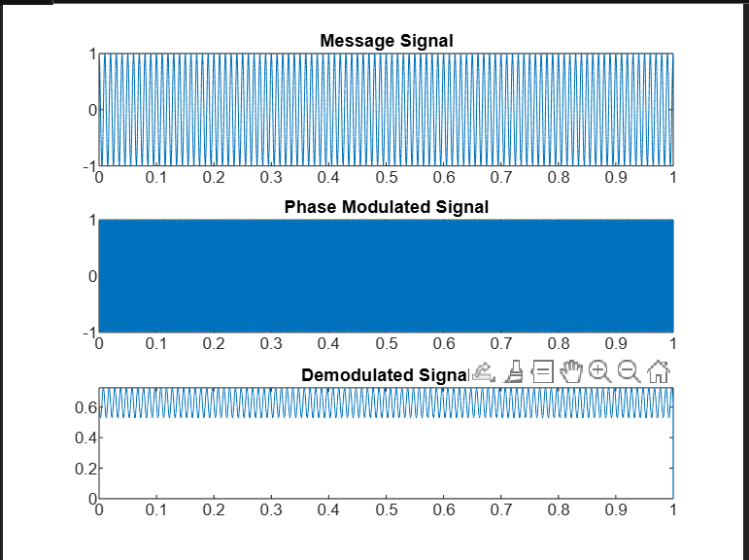

**Discussion:**

This lab successfully demonstrated Phase Modulation (PM) and its demodulation using MATLAB. The results showed how the message signal influences the phase of the carrier wave. The demodulated signal closely matched the original message, confirming accurate recovery. PLL-based demodulation proved effective but may introduce slight phase lag. Overall, PM is a robust technique, especially in noise-resistant communication systems.